Image | 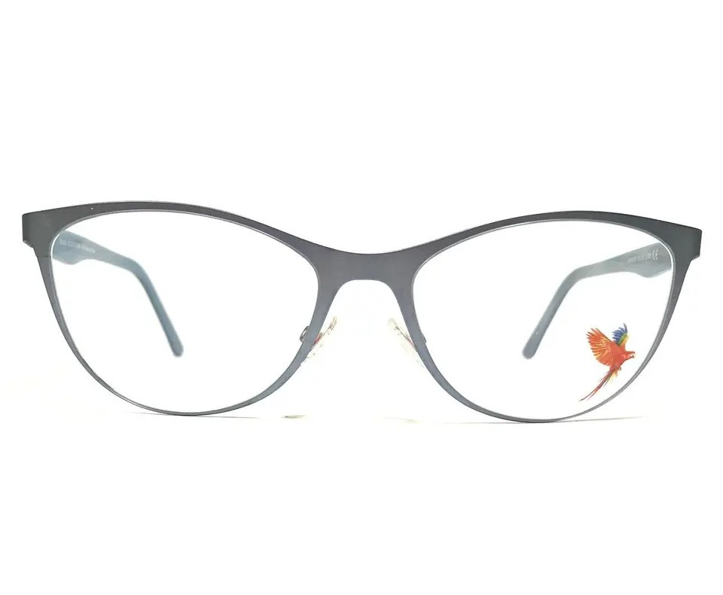
Brand | TIFFANY & CO.
Model Name | MJ 02105
Price | RS 1449
PRODUCT DETAILS

